21BCE6061
Darshan J Patel

OS Lab – 3

Code -
//Used for basic input/output stream
#include <stdio.h>
//Used for handling directory files
#include <dirent.h>
//For EXIT codes and error handling
#include <errno.h>
#include <stdlib.h>

void _ls(const char *dir,int op_a,int op_l)
{
//Here we will list the directory
struct dirent *d;
DIR *dh = opendir(dir);
if (!dh)
{
if (errno = ENOENT)
{
//If the directory is not found
perror("Directory doesn't exist");
}
else
{
//If the directory is not readable then throw error and exit
perror("Unable to read directory");
}
exit(EXIT_FAILURE);
}
//While the next entry is not readable we will print directory files
while ((d = readdir(dh)) != NULL)
{
//If hidden files are found we continue
if (!op_a && d->d_name[0] == '.')
continue;
printf("%s ", d->d_name);
if(op_l) printf("\n");
}
if(!op_l)
printf("\n");
}
int main(int argc, const char *argv[])
{
if (argc == 1)
{
_ls(".",0,0);
}
else if (argc == 2)
{
if (argv[1][0] == '-')
{
//Checking if option is passed
//Options supporting: a, l
int op_a = 0, op_l = 0;
char *p = (char*)(argv[1] + 1);
while(*p){
if(*p == 'a') op_a = 1;
else if(*p == 'l') op_l = 1;
else{
perror("Option not available");
exit(EXIT_FAILURE);
}
p++;
}
_ls(".",op_a,op_l);
}
}
return 0;
}

Output

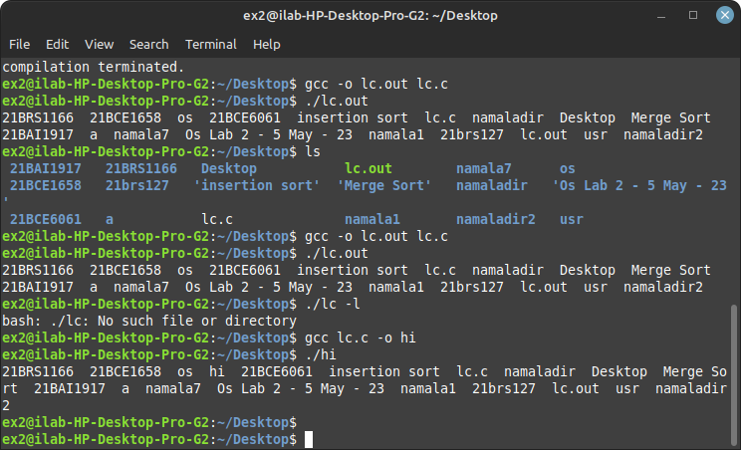
Q – 2
Cat command
code -
#include <sys/types.h>
#include <sys/stat.h>
#include <stdio.h>
#include <fcntl.h>
#include <unistd.h>

int main(int argc, char *argv[])
{
int fd, i;
char buf[2];

if (argc != 2) {
printf("Usage: %s <filename>\n", argv[0]);
return 1;
}

fd = open(argv[1], O_RDONLY);

if (fd == -1) {
perror("open");
return 1;
}

while ((i = read(fd, buf, 1)) > 0) {
printf("%c", buf[0]);
}

close(fd);

return 0;
}

Output -

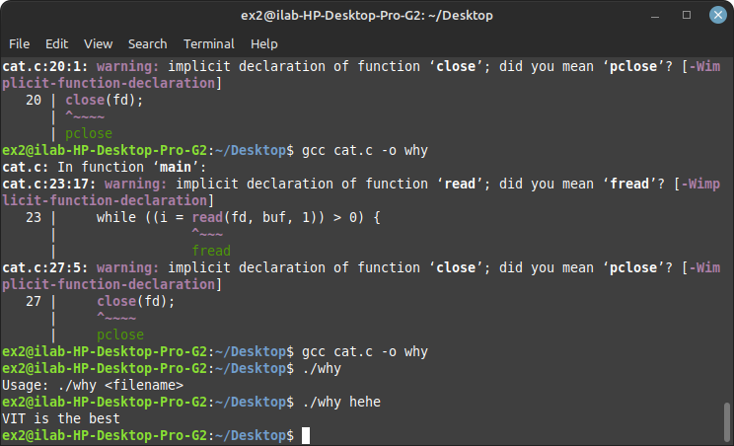
Question – 3

code -

#include <stdio.h>
#include <string.h>

#define MAX_FILENAME_LENGTH 100
#define MAX_PATTERN_LENGTH 100
#define MAX_LINE_LENGTH 200

int main() {
char filename[MAX_FILENAME_LENGTH], pattern[MAX_PATTERN_LENGTH], line[MAX_LINE_LENGTH];
FILE *fp;

printf("Enter file name: ");
scanf("%s", filename);

printf("Enter the pattern to search: ");
scanf("%s", pattern);

fp = fopen(filename, "r");

if (fp == NULL) {
printf("Error: Unable to open file.\n");
return 1;
}

while (fgets(line, sizeof(line), fp)) {
if (strstr(line, pattern)) {
printf("%s", line);
}
}

fclose(fp);
return 0;
}

Ouput -
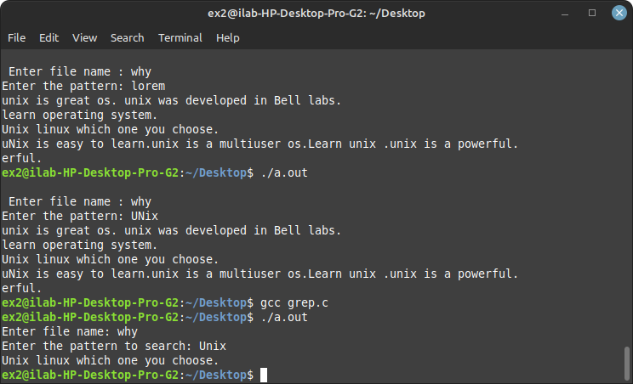
Question – 4
Code -
#include <stdio.h>

int main() {
FILE *sourceFile, *targetFile;
char sourcePath[100], targetPath[100];
char buffer[1024];
int numBytes;

printf("Enter source file path: ");
scanf("%s", sourcePath);

printf("Enter target file path: ");
scanf("%s", targetPath);

// Open source file for reading
sourceFile = fopen(sourcePath, "rb");
if (sourceFile == NULL) {
printf("Unable to open source file.\n");
return 1;
}

// Open target file for writing
targetFile = fopen(targetPath, "wb");
if (targetFile == NULL) {
printf("Unable to create target file.\n");
fclose(sourceFile);
return 1;
}

// Copy contents from source to target file
while ((numBytes = fread(buffer, 1, sizeof(buffer), sourceFile)) > 0) {
fwrite(buffer, 1, numBytes, targetFile);
}

// Close file pointers
fclose(sourceFile);
fclose(targetFile);

printf("File copied successfully.\n");

return 0;
}
Output -
